Core Router Configuration
Step 1:
Default IP: 192.168.88.1 in browser through SFP port 1 using CAT 6 cable
User :
Password :
Reset Router from GUI --- system – reset configuration or hardware button press

Step 2:
Select Interface – Rename Interface --- SFP 1 for management
SFP2 to dis1
SFP3 to dis1
SFP4 to dis1
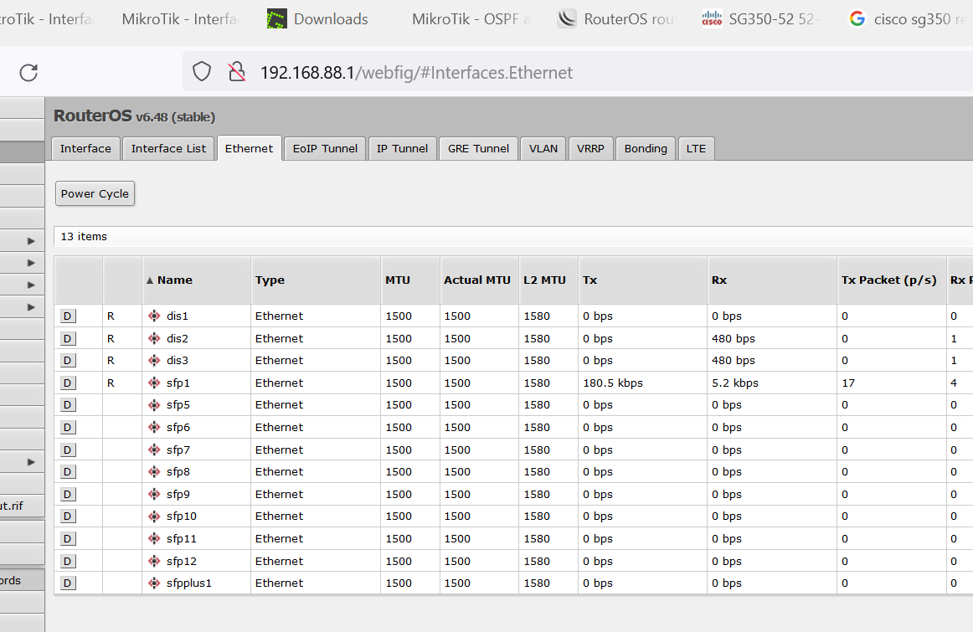
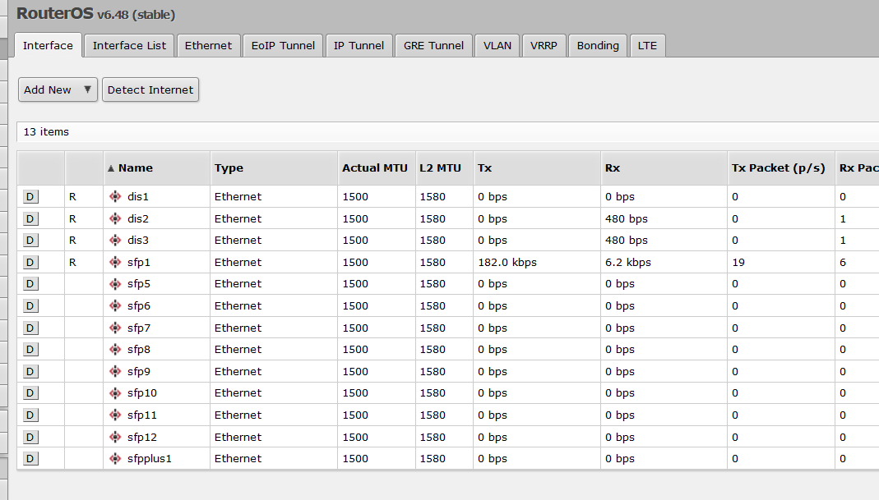

IP address:
Core Router (Server Room)
GE0/3 | 103.133.254.2 | 255.255.255.0
GE0/0 | 10.28.88.1 | 255.255.255.248 |  | 10.28.88.0/21
GE0/1 | 10.28.88.9 | 255.255.255.248 |  | 10.28.88.8/22
GE0/2 | 10.28.88.17 | 255.255.255.248 |  | 10.28.88.16/23
Assign IP address to Interfaces
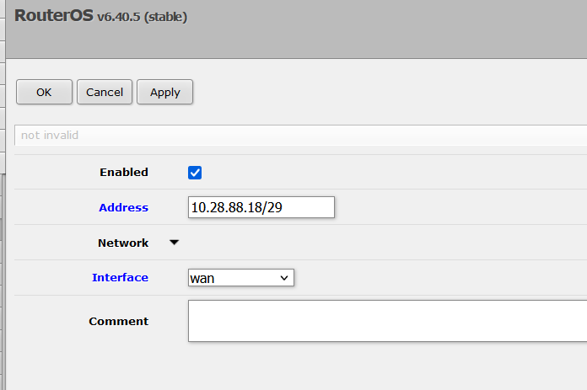
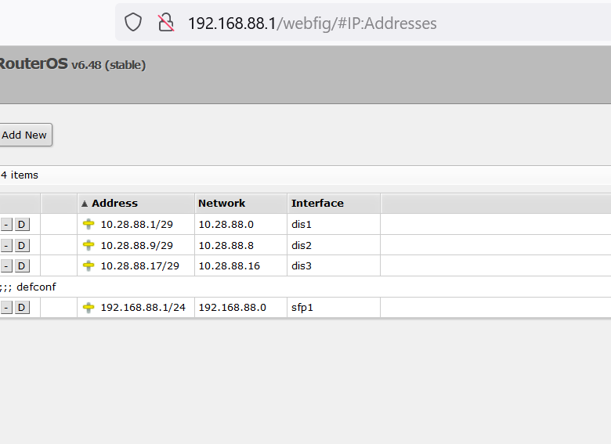

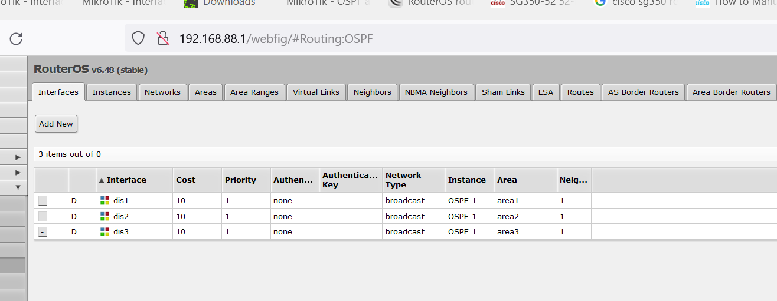
Step : go to routing then select OSPF
Create instances

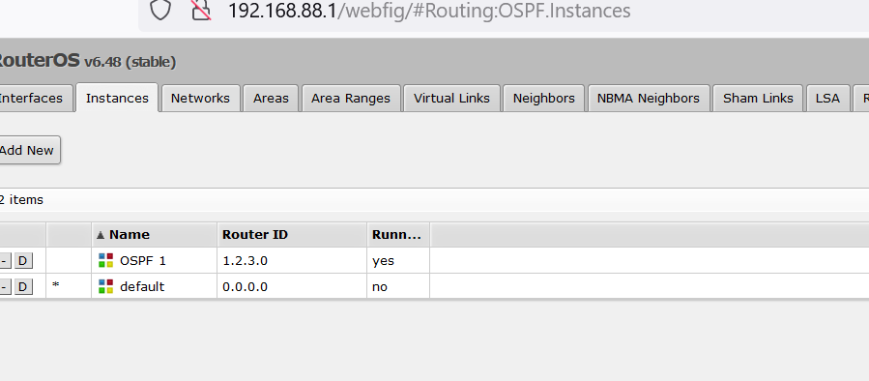
Create area
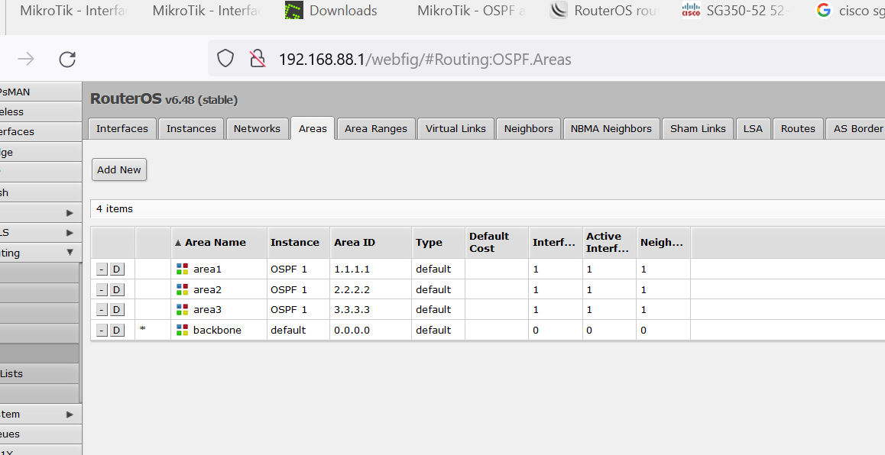
Add network
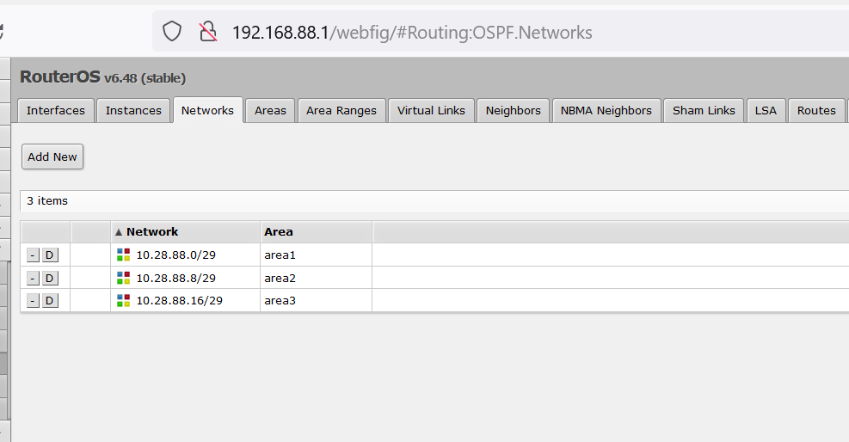
Interface list
